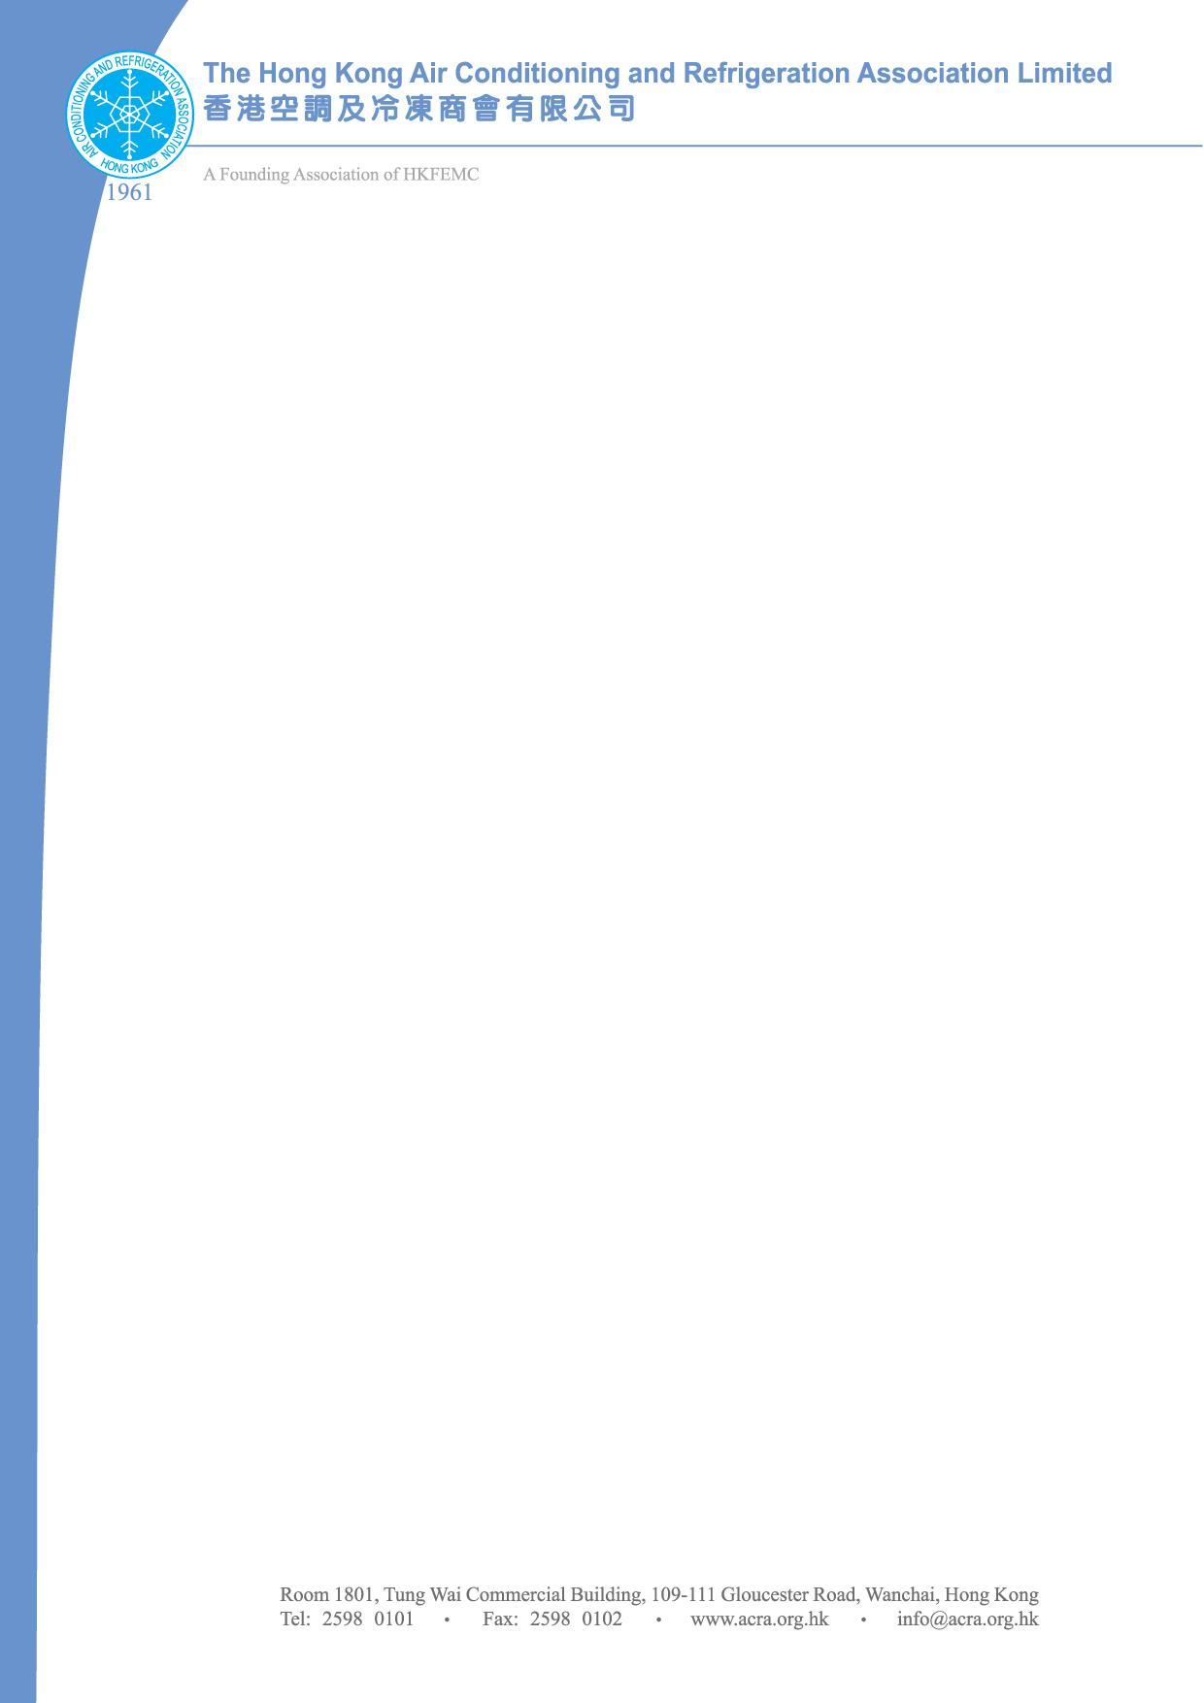
24 January 2011

TO: All ACRA Members

ACRA Spring Dinner 2011

The Chinese New Year is round the corner. To welcome and celebrate the Year of Rabbit, we would like to invite you to join our ACRA Spring Dinner 2011 on 25th February 2011 (Friday). Details are as follows:

Date: 25th February 2011 (Friday)
Venue: The South China Hotel – Hsin Kuang Banquet Hall
北角粵華酒店新光宴會廳
1/F, The South China Hotel, 67-75 Java Road, North Point, Hong Kong
Time: 5:00 p.m. – 7:00 p.m. Cocktail Reception & Karaoke Competition
8:00 p.m. – 10:30 p.m. Dinner

Please kindly confirm your attendance by returning the attached Reply Slip before 18 February 2011. The reservation will be at first come first served basis. Should you have any queries, please feel free to contact our Ms Polly Mui at 2598 0101 or the undersigned at Tel: 9104 3973.

Look forward to seeing you on 25th February 2011.

With May Warmest Regards

Ken Tsang
Ken Tsang
Organizing Committee of Spring Dinner 2011
The Hong Kong Air Conditioning &
Refrigeration Association

KT/pm

To : The Hong Kong Air Conditioning & Refrigeration Association

Fax to : Ms Polly Mui - Fax no.: 2598 0102 Tel: 2598 0101
E-mail Reply: pollymui@acra.org.hk

Reply Slip

ACRA Annual Spring Dinner 2011

( ) I will attend the 2011 Spring Dinner.
~ HK$380.00 for a seat
~ I would like to reserve _____ seat(s) for the dinner with total amount
HK$_____________.

Please prepare a crossed cheque payable to ‘The Hong Kong Air Conditioning and Refrigeration Association Limited’ and send to Ms Polly Mui at Room 1801, Tung Wai Commercial Building, 109-111 Gloucester Road, Wanchai, Hong Kong.

Please kindly confirm your attendance by returning the attached Reply Slip on or before 18 February 2010.

Company Name(Block letters):
Contact Person (Block letters):
E-mail:
Mobile Phone:

Signature: ______________________________

Date: __________________________________

