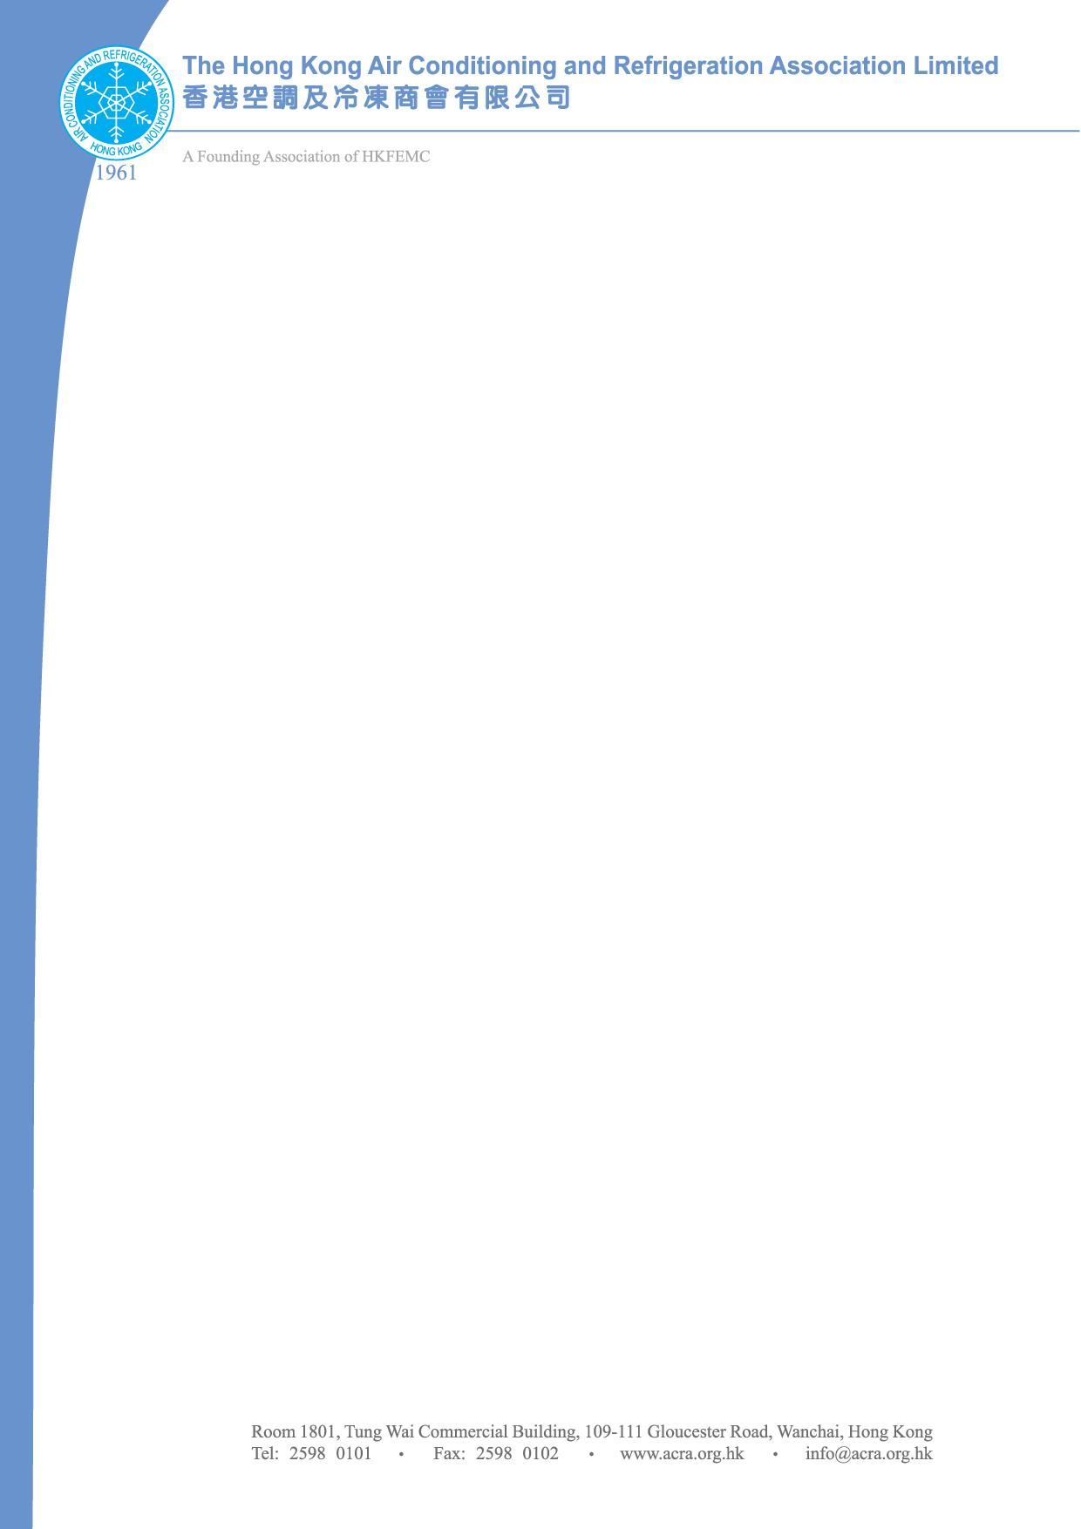
24th January 2011
To : The Hong Kong Air Conditioning and Refrigeration Association

Fax To : Ms. Polly Mui - Fax No.: 2598-0102 Tel. No.: 2598-0101

ACRA SPRING DINNER 2011
DONATION FOR TABLE PRIZE & LUCKY DRAW

We would like to donate the following prize(s) for the Lucky Draw at the ACRA Spring Dinner 2011 held on 25th February 2011
Item | Description | Quantity

We will deliver the prize(s) to ACRA Wanchai office on or before 22 February 2011.
The Hong Kong Air-condioning & Refrigeration Association Ltd.
Room 1801, Tung Wai Commercial Building, 109-111 Gloucester Road, Wanchai, Hong Kong
Attn : Ms. Polly Mui

*Please send us in form of coupons for those bulky / heavy prizes.
Company Name (Block letters):
Contact person (Block letters):
Contact Tel:
Date: | Signature:

To make full use of the venue, as usual we shall provide some space for our members to put their roller banner stands to promote their products and/or services. The price for each roller banner stand is HK$500. Please indicate your interest to use this service by putting a tick at below.
Yes, we are interested in this service | Roller Banner Stand  (Material are not provided)  Size:1m (W) x 2m (H) | HKD500.00/stand | Quantity:  _________ Nos.

