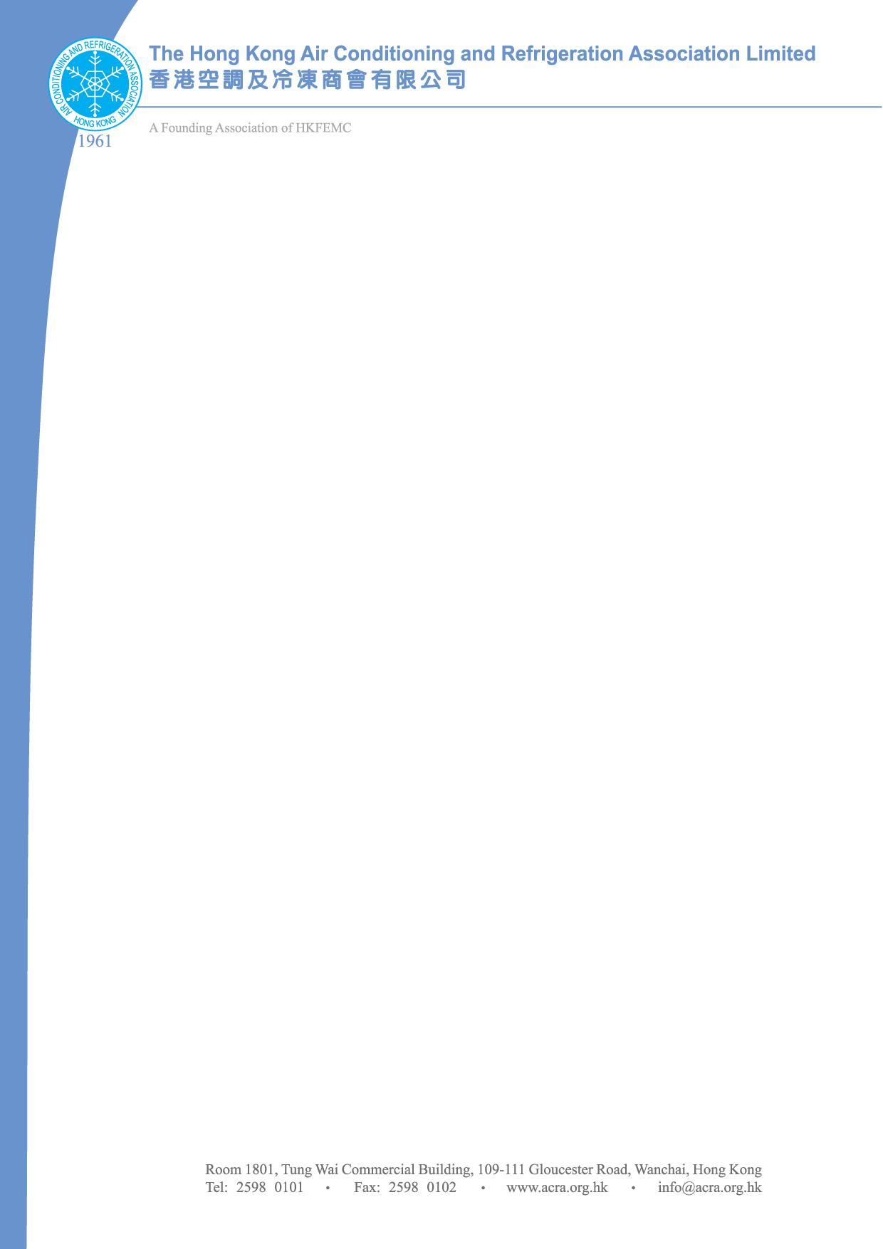

Reply Slip

To: ACRA (Fax: 2598 0102 / Email: pollymui@acra.org.hk)

Annual General Meeting 8 June 2012

Date : 8 June 2012 (Friday)

Time : 4:00 pm

Venue : Room 1801, Tung Wai Commercial Building,

109-111, Gloucester Road, Wanchai, Hong Kong

香港灣仔告士打道109-111號東惠商業大廈1801室

Company :

Name of Representative :

Authorized Signature :
Contact Tel : |  |  |  | Fax : |  | E-mail :

(Note For Appointing a Proxy):

Please note that the proxy MUST BE completed in full and reach ACRA prior to the meeting.

- I shall attend the AGM.

- I am unable to attend the AGM, but will appoint a proxy.

(Name of Proxy: _____________________________)

- I am unable to attend the AGM.

