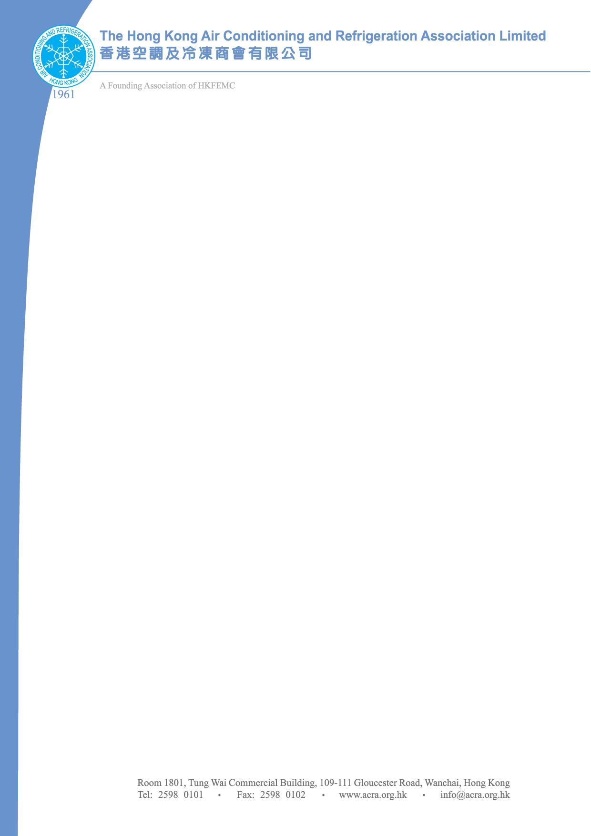

To: The ACRA Election Committee
c/o Polly Mui
email: pollymui@acra.org.hk
Fax: 2519 0298

The Hong Kong Air Conditioning and Refrigeration Association Ltd.
Nomination Form for Council 2012-2014

Please note that all Nominations MUST reach the Election Committee Forty-Eight (48) Hours prior to the AGM, i.e. on or before 6 June 2012.

Name of Nominees:

President | :
Chairman | :
Immediate Past President | : | Young’s Engineering Co., Ltd.
Vice Presidents | : | 1) |  | 2)
Treasurer | :
Secretary | :

Council Members:
1 |  | 2
3 |  | 4
5 |  | 6
7 |  | 8
9 |  | 10
11 |  | 12
13

Submitted By | :
Signature | :
Class of Membership | :
Date | :

